7Xi Re-encode UPCAUPCA

EAN/UPC - Re-encoding UPC-A, UPC-E, EAN-8 - UPC-A transmitted as UPC-A
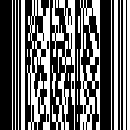
<SW>4B5A00

